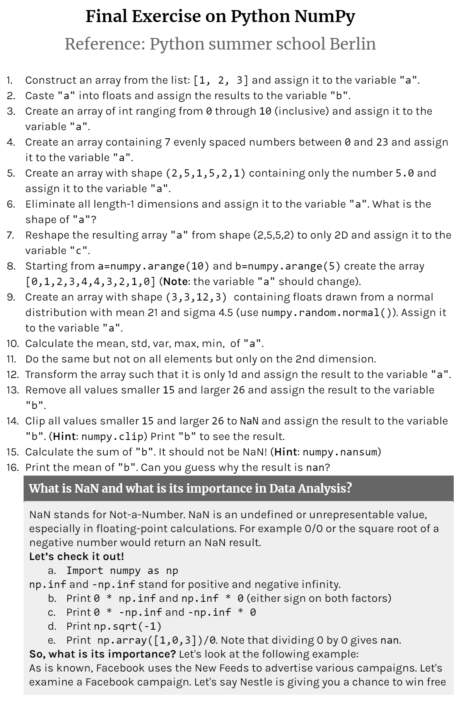

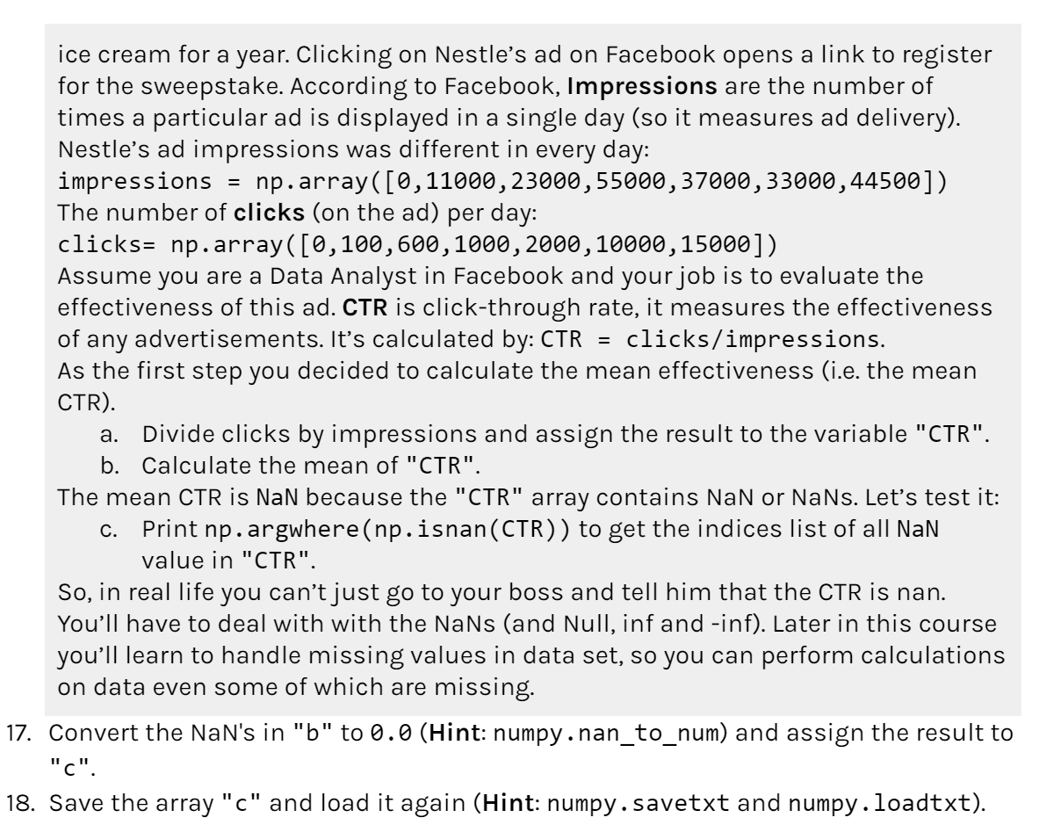

For more 100 Numpy exercises:

<https://github.com/rougier/numpy-100>